Summary of Findings from IDA ICE

Following the “INL1-2 Building Energy Needs” video tutorial, I did the baseline as well as other adjustments to experiment with and see how different values change with parameters.

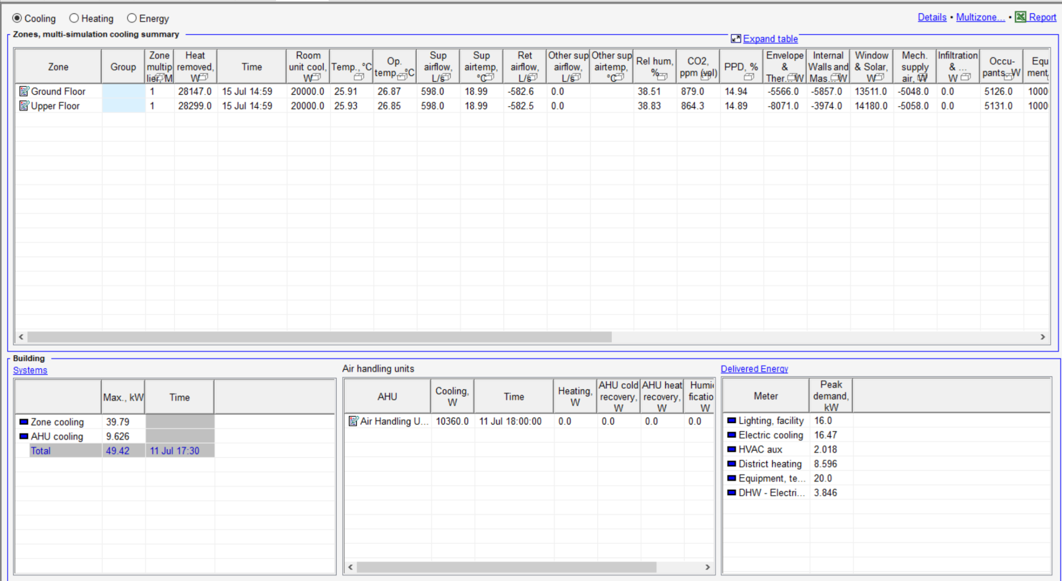
Baseline Condition
Cooling

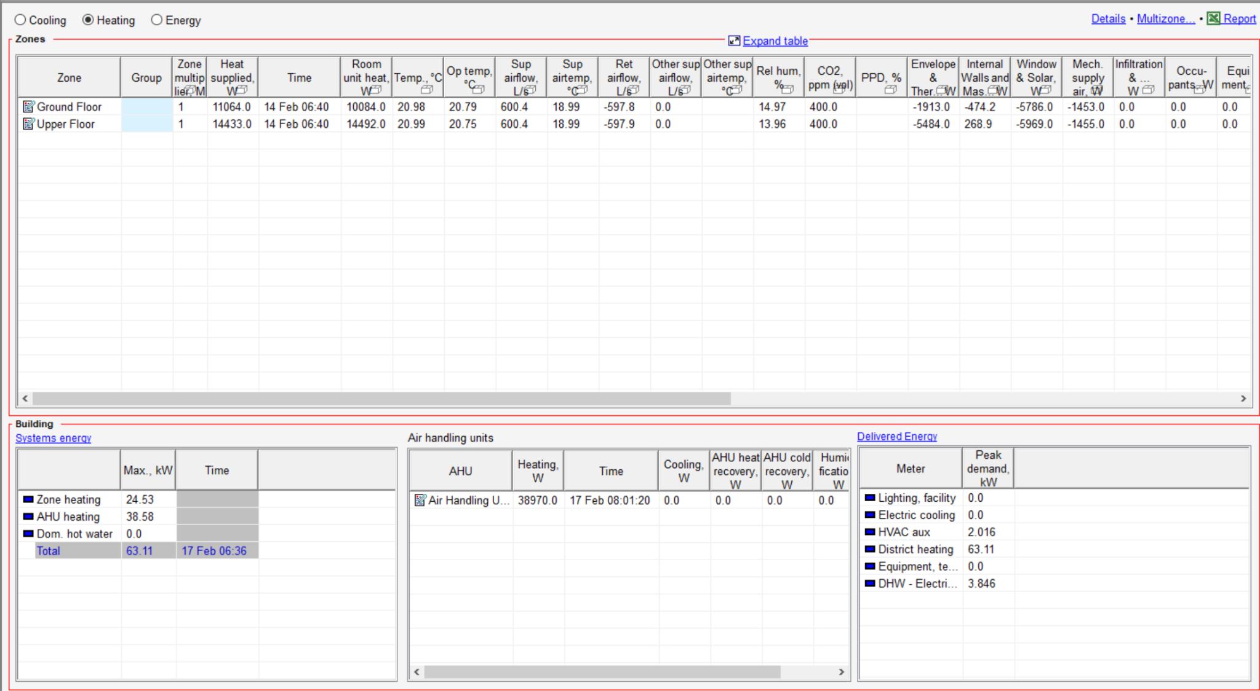
Heating
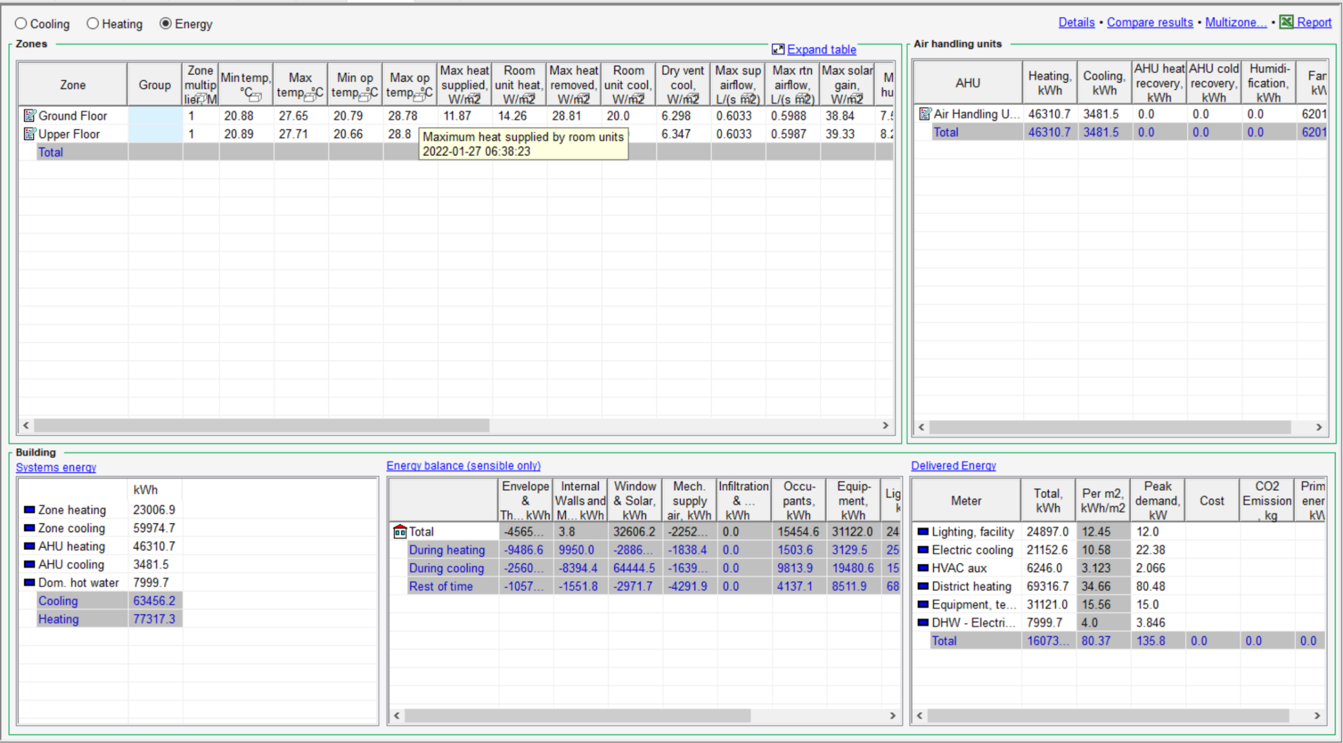
Energy

The baseline conditions were achieved by changing maximum cooling and heating power to get the desired Predicted Percentage of Dissatisfaction (PPD) value (~6%). After this the maximum power conditions are fixed and other changes are made to see their influence in heating, cooling, and energy.

Task Conditions and Observations

Addition of Heat Exchanger
The addition of a Heat Exchanger (Heat Exchanger Effectiveness = 0.7) to the Air Handling Unit reduced the AHU Power from 38.58 KW to 8.593 KW. It also reduced the District Heating peak demand from 63.11 KW to 32.81 KW. It also affected the Total Delivered Energy as it decreased from 160733 KWh to 118889.9 KWh.

Addition of Window Shade
The addition of External Blinds to the baseline condition did not show any promising changes to the values.

Change of Orientation of the Building
The building on the baseline is facing east to west. If we change it to face North to south, not much changes from the baseline conditions apart from a slight increase in all values.

Change in location
Due to the change in location we need to find the new baseline condition based on the PPD values. After balancing the maximum heating and cooling we come to the conclusion that no heating power is required in this building if it is in Barcelona as the PPD values are below 15%. And a cooling power of 40 KW on the ground floor and 50 KW on the upper floor is required to bring PPD values to 15%.

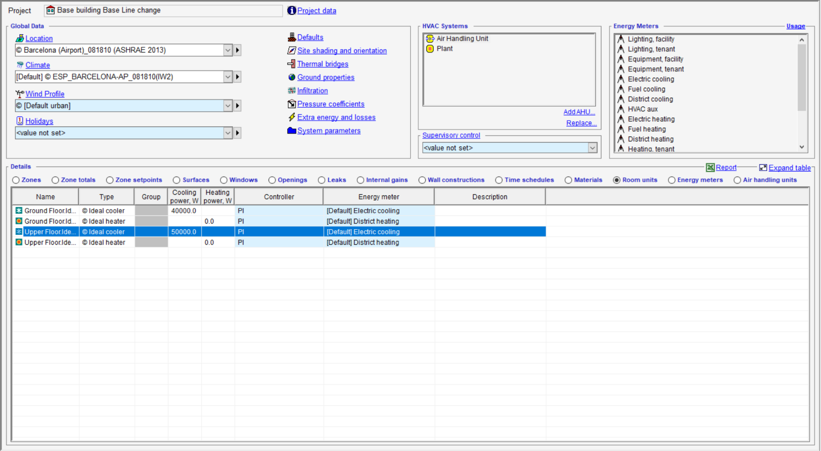
Location changed to Barcelona

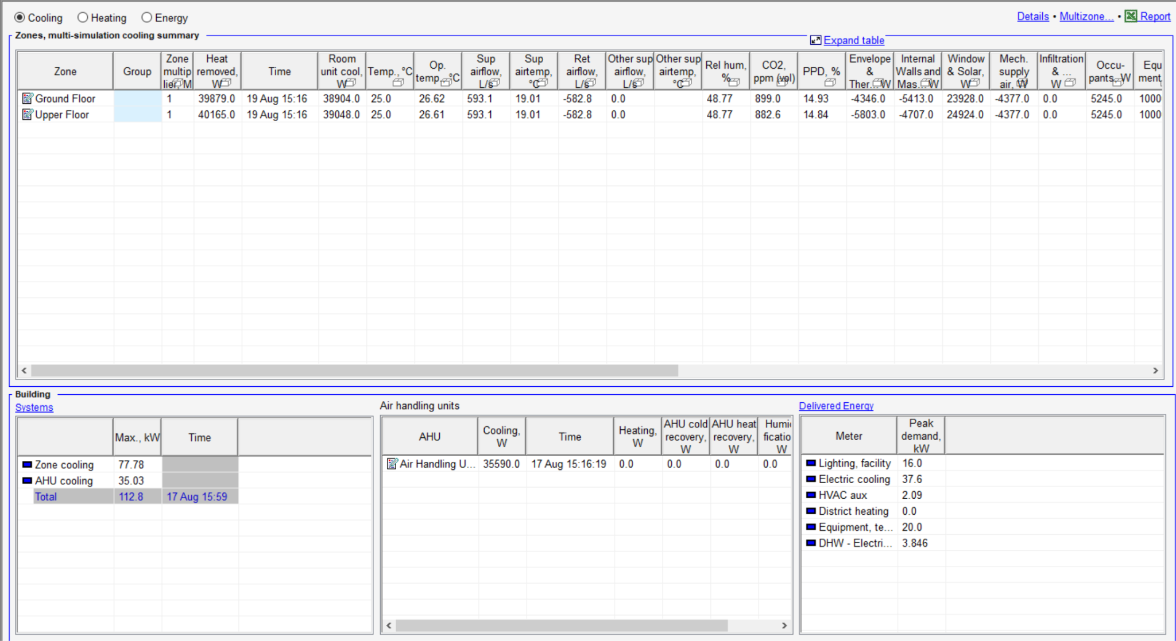

Cooling

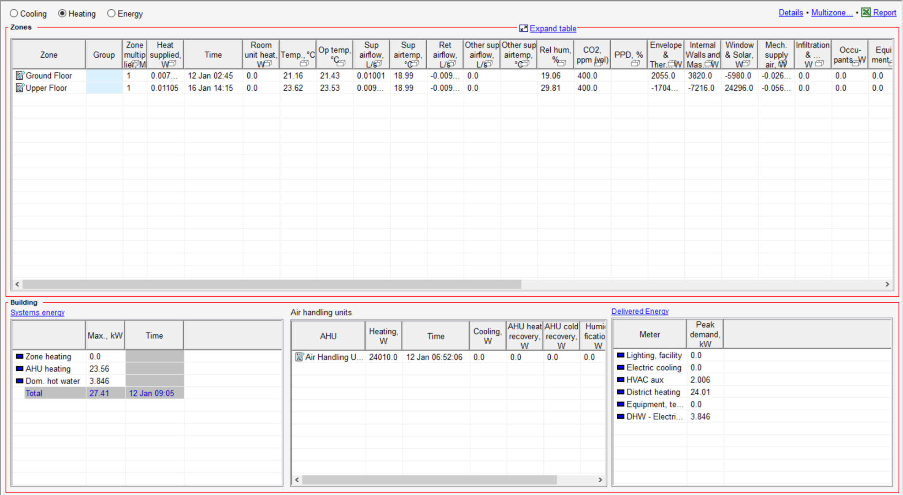

Heating

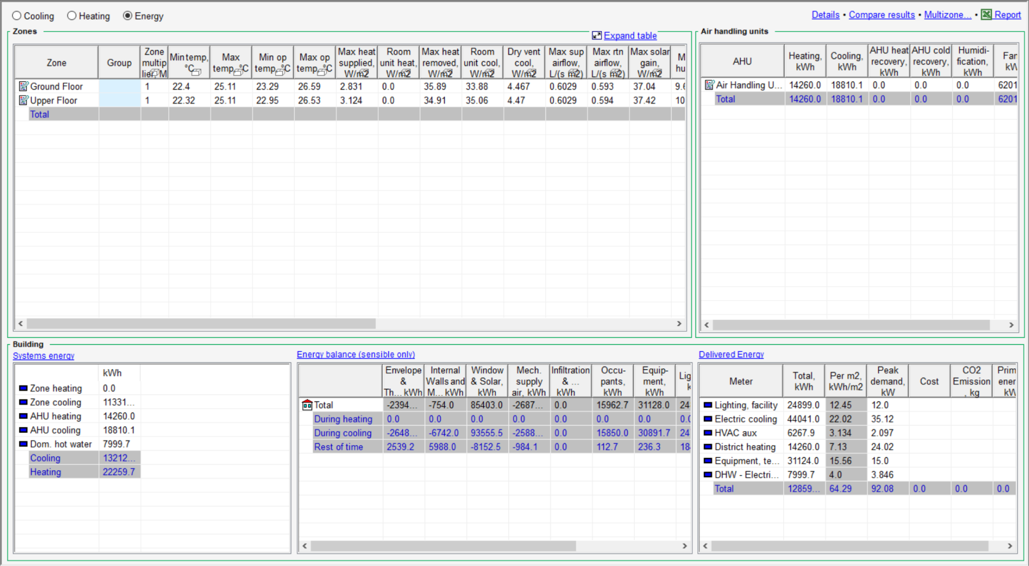

Energy

